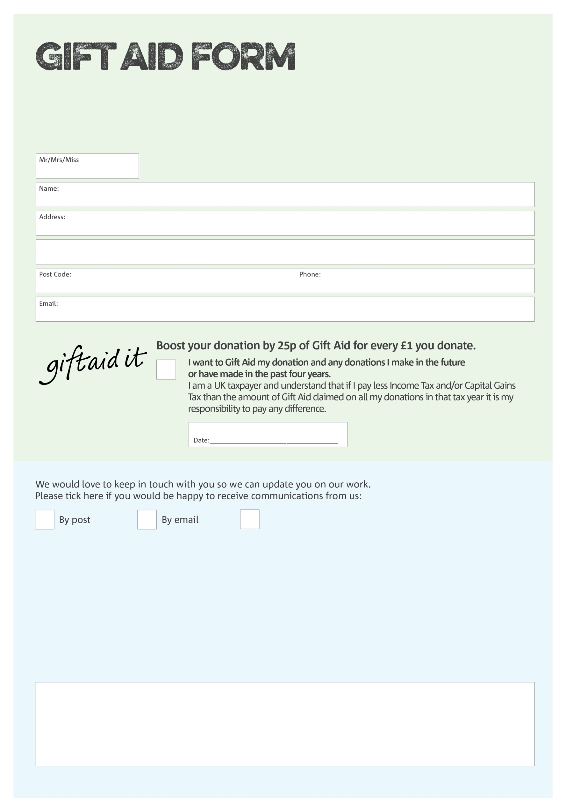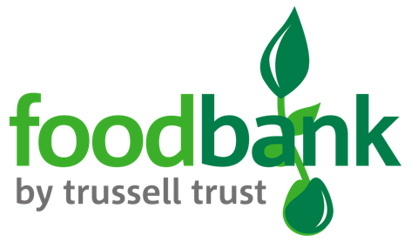

By filling in this form Brentwood Foodbank will receive an extra 25p for every £1 you give at no extra cost to you. Thank you!

I want Assemblies of God Incorporated, on behalf of Brentwood foodbank to treat as Gift Aid all qualifying gifts of money I have made from the date of this declaration and in the past four years. I am a UK taxpayer and understand that if I pay less Income Tax and/or Capital Gains Tax than the amount of Gift Aid claimed on all my donations in that Tax year it is my responsibility to pay any difference.

Breakthru Church. Also trading as Brentwood foodbank .A company limited by guarantee and registered in England and a registered Charity. Registered Company Number: 08259019. Registered Charity Number: 1149850. Registered Office at 250 Ongar Road, Brentwood, Essex. CM15 9DX

**Data protection**

*Brentwood Foodbank is committed to protecting your privacy and will process your personal data in accordance with current Data Protection legislation. Brentwood Foodbank collects information to keep in touch with you and supply you with information relating to our work. To unsubscribe from our newsletter, send a message to the email address above with the word unsubscribe in the subject line. A full data privacy statement for financial donors is available from the foodbank on request.’*

You can change your preferences any time by contacting us on 01277 229189 or emailing us at

admin@breakthru-church.com

I do not wish to receive future communications from Brentwood Foodbank

We would love to know why you have chosen to donate to Brentwood Foodbank. If you would like to share your motivation let us know below: